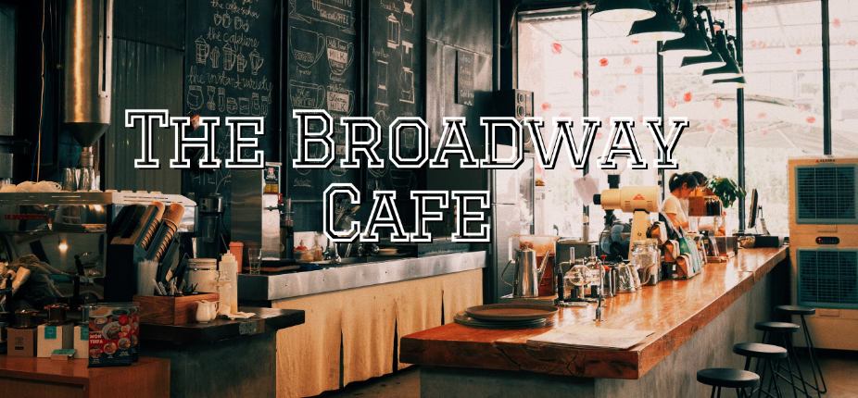

**Customer Relationship Management**

**Team 2:**

**MIS 360**

**5/31/2022**

**Dr. Grant**

# **Table of Contents**

1. Planning
   1. Problem statement……………………………………………………………..3
   2. Project scope…………………………………………………………………...3
   3. Systems request………………………………………………………………..5
   4. Assumptions…………………………………………………………………...5
   5. Feasibility analysis…………………………………………………………….6
   6. Gantt Chart…………………………………………………………………….8
2. Analysis
   1. Requirements…………………………………………………………………..8
   2. Activity diagram
      1. As is……………………………………….…………..………………11
      2. To-be…………………………………………………………………..12
   3. Use case diagram ……………………………………………………………..14
3. Design
   1. Design strategy………………………………………………………………..15
   2. Class Diagram………………………………………………………………...16
   3. Windows navigation diagram…………………………………………………16
   4. GUI and forms………………………………………………………………...19
4. Appendix
   1. Project Outline………………………………………………………………...29
   2. Team Contract…………………………….…………...……………………....30
   3. Works Cited…………………………………………………………………...31

**Planning**

## **Problem Statement**

Broadway Café has been open since the 1950s and has decided to update its traditional services. The Broadway Café continues to function as it did in the 1950s, but with an increasing number of clients, the staff finds it difficult to keep up with the orders. Because there is no computer system, data is significantly more difficult to record and track; employees must handwrite orders and receipts, making it impossible to help consumers. Because we are a tiny coffee shop, this insufficiency is costing us money and effort. As a result, the Broadway Café is introducing a new and creative customer relationship management (CRM) system. Because of the significant rise in technology and innovation in modern times, businesses must always stay up to date with evolving technologies, the management team has proposed upgrading our existing services.

Implementing new and inventive technology within the café will improve the system for workers and management while also enhancing consumer involvement. The café will upgrade its infrastructure and add these cutting-edge growth kiosks. Kiosks are self-service kiosks with touch screens that are freestanding. Our goal is to succeed in bent consumers in a very informal manner by adopting this new approach within the café. The kiosks will need the establishment of an internet website that may be accessible to consumers within the café via the kiosks yet on their own devices. This new system is going to be ready to enhance existing customers' experiences as well as attract new customers to the café.

By increasing customer interaction, service, and skill, the new customer relationship management system will offer value to the Broadway Cafe. This may boost the cafe's sales and its value. Customers are going to be able to create new accounts with the Broadway Cafe so as to get rewards and free menu items as a part of this new system.

## **Project Scope**

|  |  |
| --- | --- |
| **Project title:** The Broadway Cafe- CRM | **Team:** 2 |
| **Project leader/manager:** Insia | **Anticipated project start date:** April 25, 2022 |
| **Sponsor:** Esther | **Date prepared:** May 15, 2022 |
| **Project risk level:** Low | **Estimated completion date:** May 30, 2022 |

|  |
| --- |
| **Team members:**   * Mohammad Ganny * Insia Haroon * Shriyadita Malisetty * Shreya Rawal * Alexander Sereleas * Vacha Thakkar * Jawad Yousuf * Melary Vasquez |
| **Background:** The cafe workers are unable to take orders in a timely manner. So, therefore, a new computer system needs to be implemented in order for a new order to be followed. |
| **Scope description:**   * Project budget increases * Implement   + Security   + Safety   + Technology   + Staff training   + Kiosk * Prepare a budget plan |
| **Deliverables:**  The CRM system we're installing at the café is software that the management team and customers may access directly. Digital kiosks are being used as part of the CRM system. The kiosks can assist the café staff to reply to customers quickly using the information they submit on this self-service system.  Kiosks will be user-friendly, allowing people of all ages to easily move around the system, which includes a website. This new technology will allow the café to keep track of customer information and collect statistics via the kiosk. Customers will be able to sign up for a rewards account through this system, improving customer engagement and loyalty. Finally, the café's database and customer relationship management will be improved. |
| **Stakeholders:**   * Customers * Cafe staff and Management * Project manager * Project sponsor |

|  |
| --- |
| **Systems Request** Customer Relationship Management |
| **Project Sponsor:** Melary Vasquez  **Business Need:**  An increase in the number of customers has resulted in an increase in the workload for employees with the café's current system. A new system should be created for the technological advancement of the café. Implementing this project will improve the café’s customer service and reduce customer waiting times.  **Business Value:**   * Expected increase in customer satisfaction. * Attract new customers into the café. * Reduce labor costs. * Increase in the number of annual sales (20-25%)   **Business Requirements:**  By using the kiosks customers should be able to search for food and beverages and complete their orders. The new CRM system should do the following:   * Record dates/times of follow-up customer requests. * Provide customer assistance. * Provide an easier way to track customer engagement. * Record all transactions and client information.   **Special Issues or Constraints:**   * Software and hardware application. * Budget and time constraints. |

## **Assumptions**

We assume that our new CRM system will greatly improve customer engagement and so result in an expansion of our customer base. Furthermore, we also assume that our new system will reduce customer wait times and increase customer satisfaction.

We also expect customers to review our new system and be able to provide their feedback as our system may have room for improvement.

Additionally, we expect our new marketing campaigns to reach a larger network of potential clients because they will be catered to our client's interests, as their information is drafted by our system and stored in our database. This will result in an increase in café visits and annual sales.

## 

## **Feasibility Analysis**

The Broadway Cafe first opened its doors in 1952. To compete with other local coffee shops, we should integrate technologies into our business in order to bring it into the twenty-first century. To improve business operations for staff and customers, the Broadway Café project team is implementing a new Customer Relationship Management (CRM) system. To implement a new CRM system, such as a website, a feasibility study must be conducted that takes into account all of the project's relevant factors, including technical, economic, and organizational considerations.

Implementing this new CRM system at the café offers numerous benefits, which are described below:

1. Providing excellent customer service - With an optimized interface and databases, clients may find what they are seeking fast and effortlessly.
2. Centralized information database - Kiosks will allow an organization to store large volumes of data in a single location, making it easily accessible and handy.
3. Improved Sales - CRM provides for the streamlining of sales by analyzing customer data, which aids in a better understanding of customers.
4. Automation - By automating the majority of the procedures of recording and updating data, you may save time and minimize the number of errors committed manually.

**Technical Feasibility: Are we able to build it?**

Our goal of establishing a CRM system is technically viable (as shown below). Because we employed a manual approach (the previous system), implementing this new system will be less dangerous. We reasoned that employing this technique would make it easier for people to become acquainted with our website and our kiosk. Users will be more inclined to provide feedback if they have faster access to our technical assistance, and we will be able to learn more about our consumers. Our internal staff will be educated on how to utilize the system from the perspective of the user, while our external team will be trained on how to automate and export data on our users, which will aid in the resolution of any challenges or issues.

|  |  |  |
| --- | --- | --- |
| **Potential Hazards** | **Relevance to Business** | **The Risk Level** |
| **Knowledge of the Business functional areas** | Users are completely at ease with it. | Low |
| **Experience with Technology** | Users are completely at ease with it. | Low |
| **Size of the Project** | Massive undertaking | Medium |
| **Compatibility with the previous system** | Insignificant compatibility | High |

**Economic Feasibility:**

The Economic Feasibility study determines the financial costs and advantages of establishing a CRM. While hiring a team of developers and considering module expenses, we are attempting to keep expenditures within our budget. Implementing a new system is costly, thus the costs should be carefully weighed against the benefits to see whether they outweigh the costs. This study helps us decide whether or not to implement the system by assessing the project's cash flow and return on investment.

|  |  |  |
| --- | --- | --- |
| Name of developers | Description/Section | Costs |
| Front End | $20/hour | $20,000 |
| Back End | $20/hour | $20,000 |
| Sales Module | Management of Accounting and sales, and planning. Analytics | $20,000 |
| Marketing Module | Analytics, client segmentation, company management | $15,000 |
| Support Module | Agent console, customer statistics, instructions | $23,000 |
| Total development cost |  | $98,000 |

## **Gantt Chart**

# 

# **Analysis**

## **Functional Requirements**

1. **Client Data Management**

1.1 Lookup client profiles in the customer database

1.2 Recognize any issues with client data

1.3 Gather customer data from all channels in one place

1.4 Manage customer data in an organized matter

1.5 Effectively analyze consumer data

1.6 Monitor and forecast sales based on financial data

1.7 Manage customer engagements through targeted marketing in relation to data

1. **Back End Data Collection and Management**

2.1 Create service requests

2.3 Record transaction and client information

2.4 Complete customer requests

## **Non-Functional Requirements**

**1. Performance Requirements**

1. Web server must be capable of processing multiple online orders at one time.
2. Web Server should process each transaction within 10 seconds, regardless of how many orders have been placed.
3. Web Server should validate log-in credentials within 5 seconds.
4. Gather data regarding inventory and update as each order is completed.

**2.** **Operational Requirements**

1. System must be able to store and retain data such as customer orders, the amount spent per account, what was purchased (coffee, CDs, food, or retail items), and customer email.
2. Data must be easily accessible to employees for analysis.
3. System should have both online and offline point-of-sale capabilities.
4. System should run within the Windows system and store data in the Cloud.
5. *System must have 99.99% reliability. This would estimate that the server is only down for under one hour each year.
6. System must be able to put back-ordered items into a queue and let customers know of an estimated wait time.
7. System should email receipts to customers without any action from the employees.
8. Web server should reliably pass forward information to a message queue which employees can view to prepare products for customers.
9. The system developed should be easy to use for both employees and customers.
10. Inventory should automatically be updated after the cashier inserts what is being sold into the system, or customer orders from a kiosk or online.
11. The website should have ease of use capabilities and nice aesthetics to accurately portray the camaraderie and consistency of the business.

*\* Please note that according to statistics from* [*Cyberciti*](https://www.cyberciti.biz/faq/computer-network-uptime-five-nines-999999/)*, a system with 99.99% reliability would be down for about 52 minutes per year\**

**3.** **Security Requirements**

1. Only managers can access potentially personal data after undergoing training on how to deal with sensitive information.
2. Only managers not working the register can count the cash at the end of the day.
3. Only managers can approve timesheets, schedule changes, and paid time off.
4. Personal customer information should be encrypted when stored, such as passwords or payment information.
5. Only managers can order new inventory when it is running low.

## **Activity Diagram**

### **As-Is Diagram**

### **To Be Diagram**

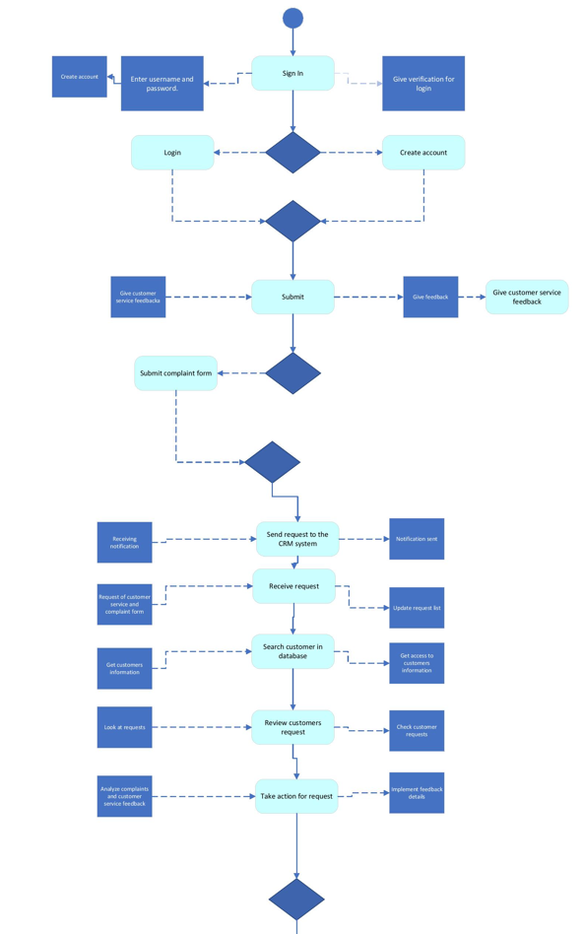

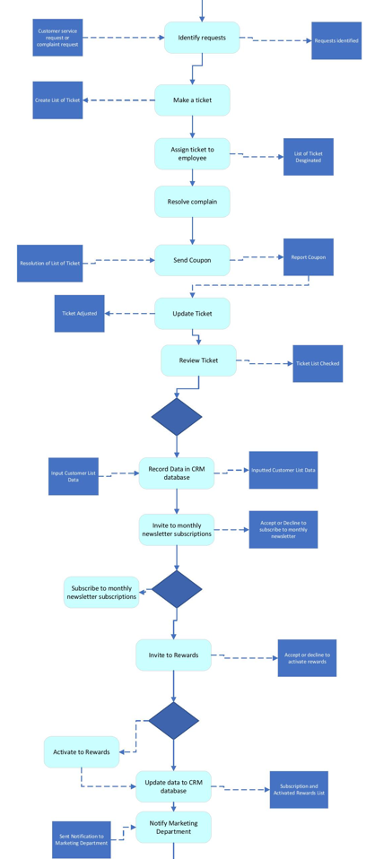

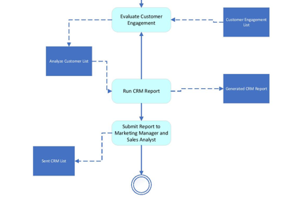

## **Use Case Diagram**

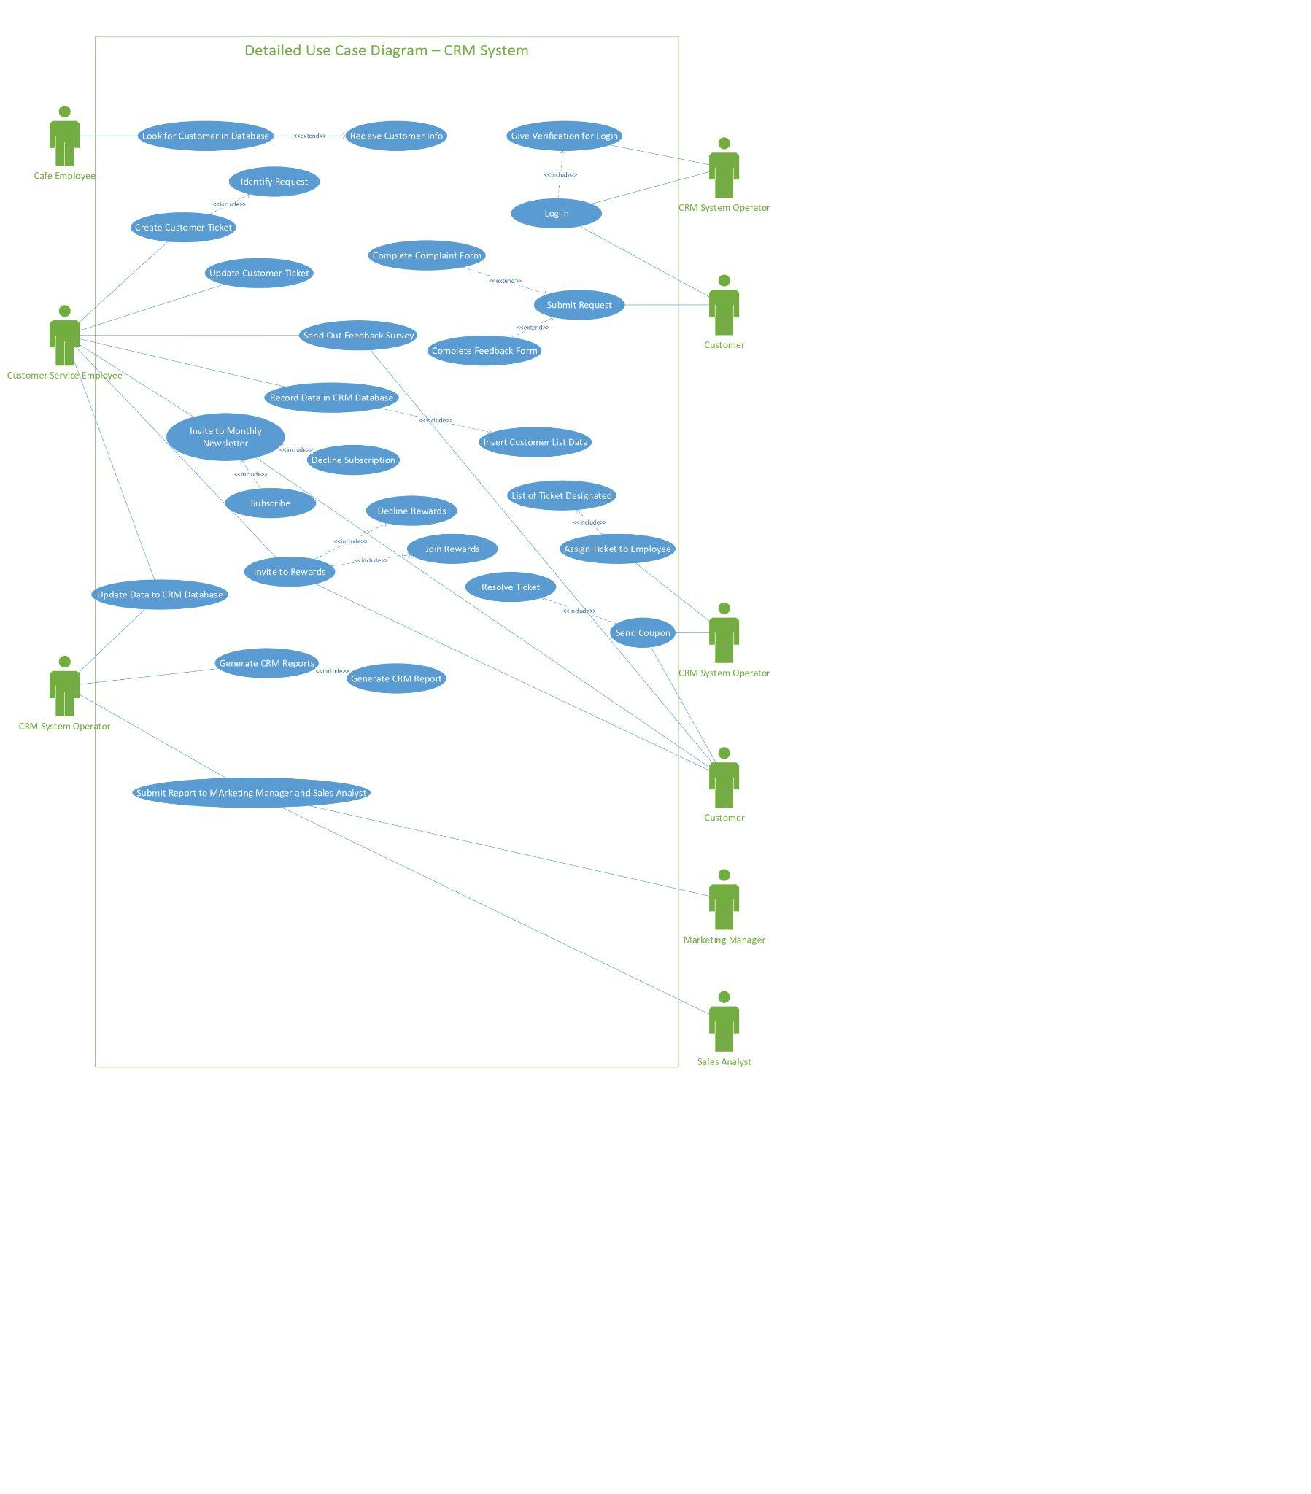

# **Design**

## **Design Strategy**

Based on the cafe’s business needs, our team decided that it would be best for Broadway Cafe to have a packaged system. The implementation of our design strategy is meant to create a more streamlined and efficient customer service experience. The new systems we’ve put in place will help maintain customer retention through feedback surveys and rewards programs with additional perks to promote more business. The new system also records customer information, so it can start to determine their preferences in order to better serve customers' needs. In terms of implementation, while we do not have the resources to code and create the system, our project manager will be on-site and ready to help supervise this project and achieve our client’s goal.

## **Class Diagram**

## 

## **Windows Navigation Diagrams**

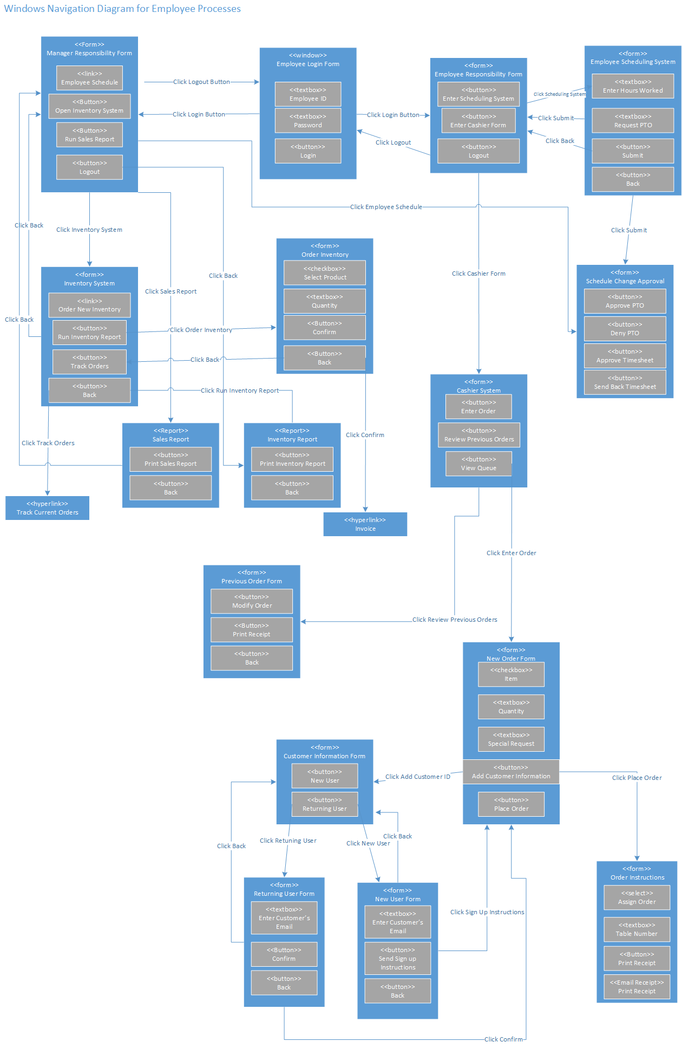

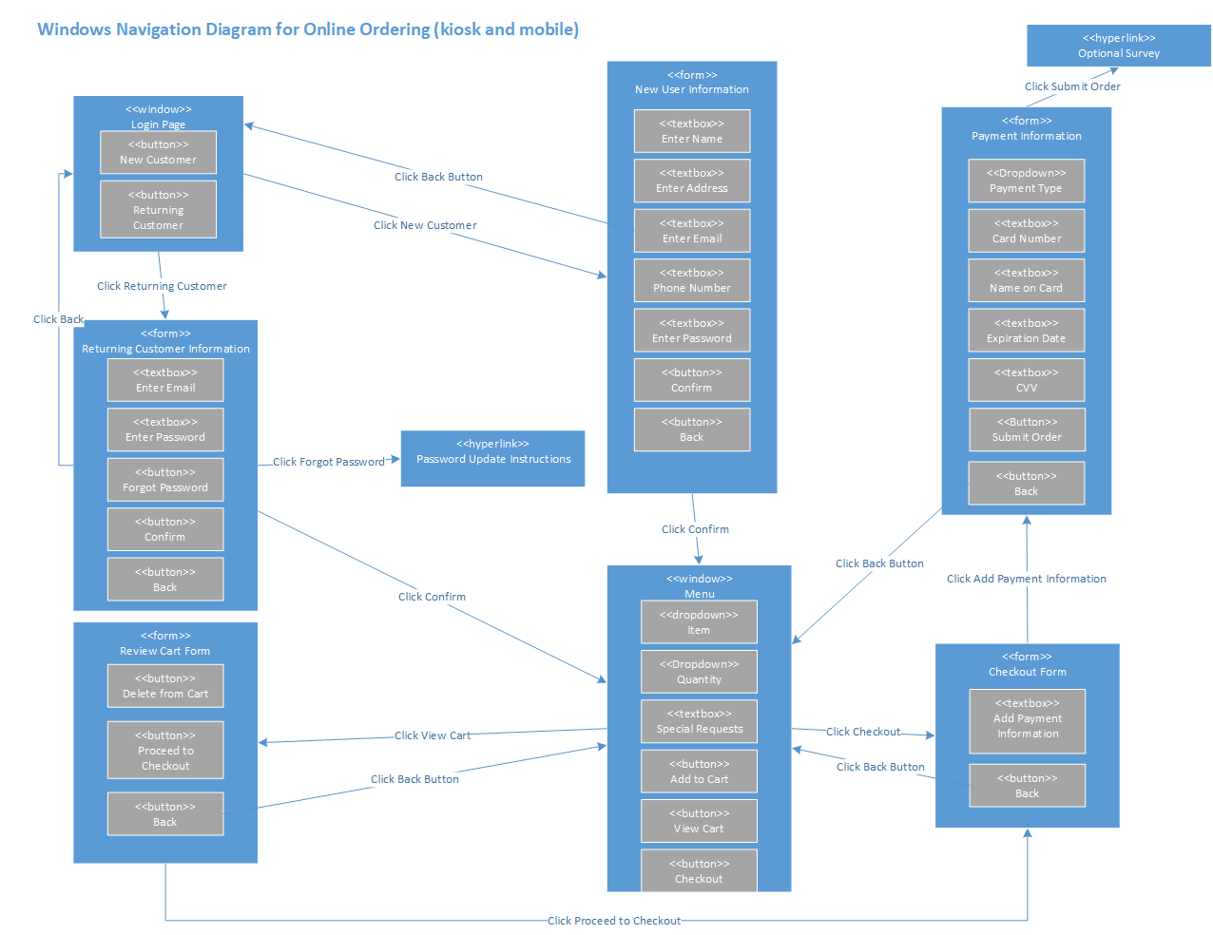

## **Front End GUI/Forms**

Home Page

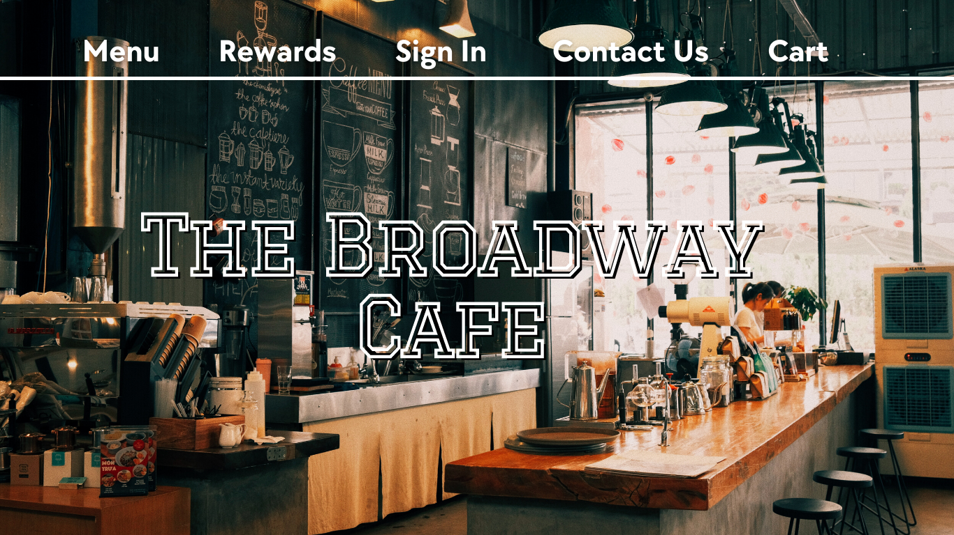

Login Page

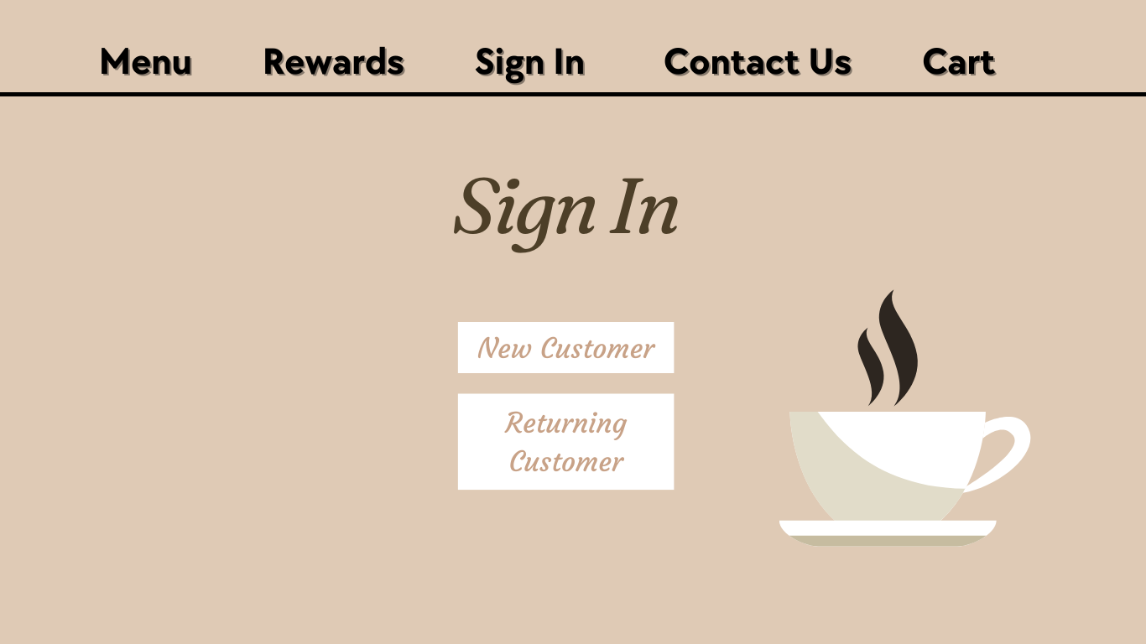

New Customer

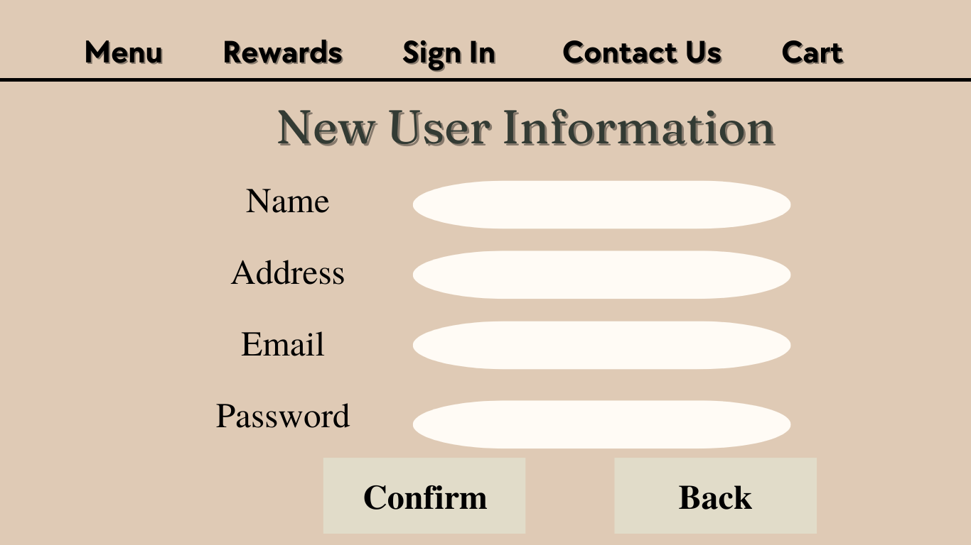

Returning Customer

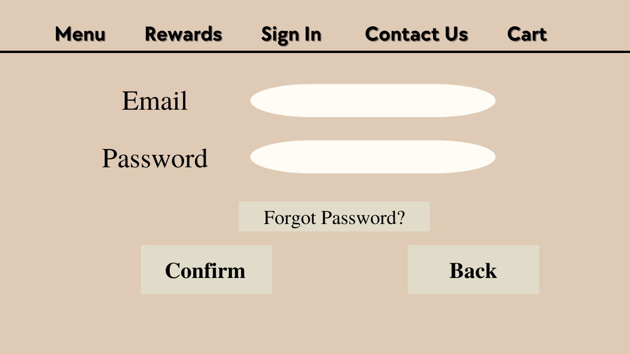

Menu

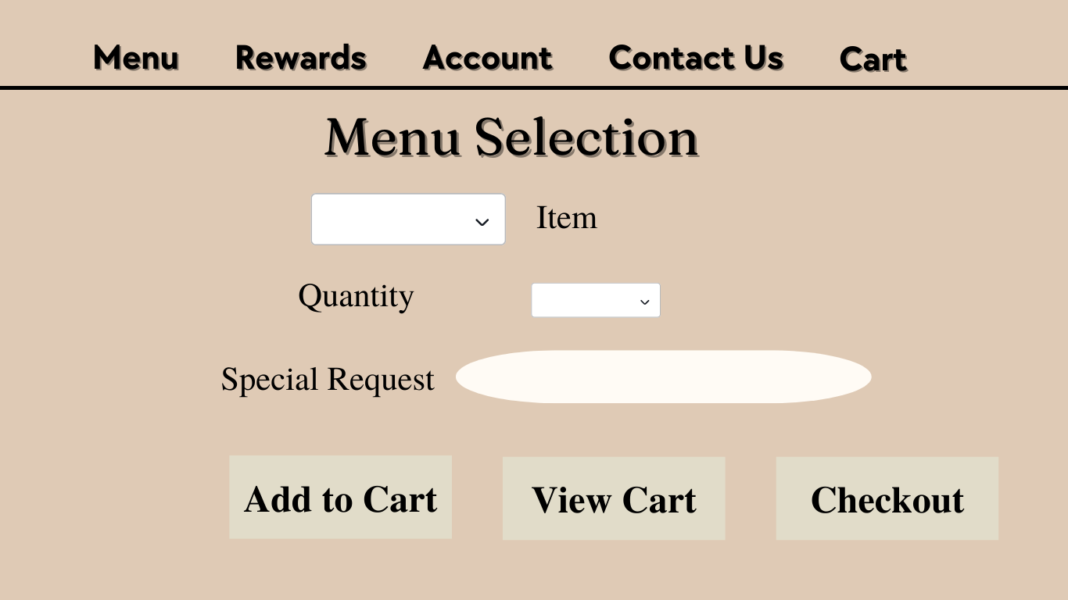

Review Cart

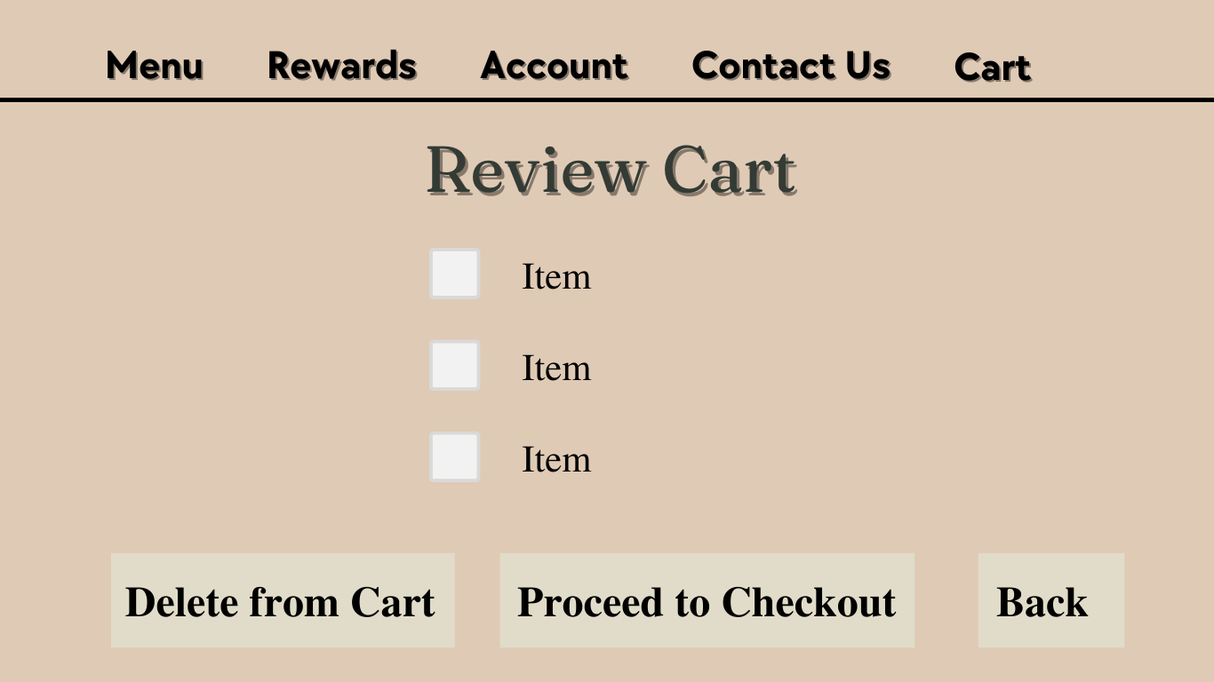

Checkout

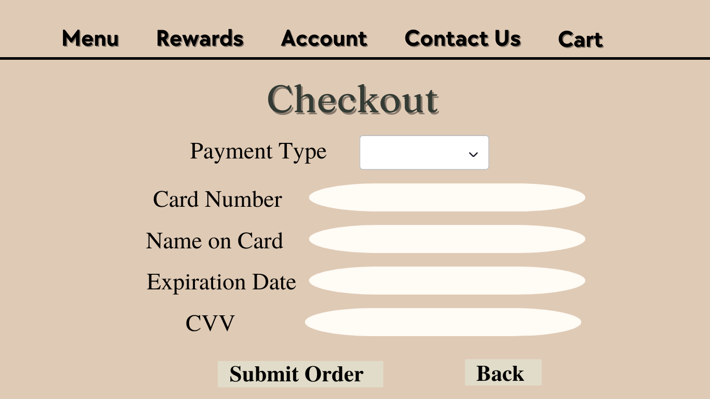

Survey

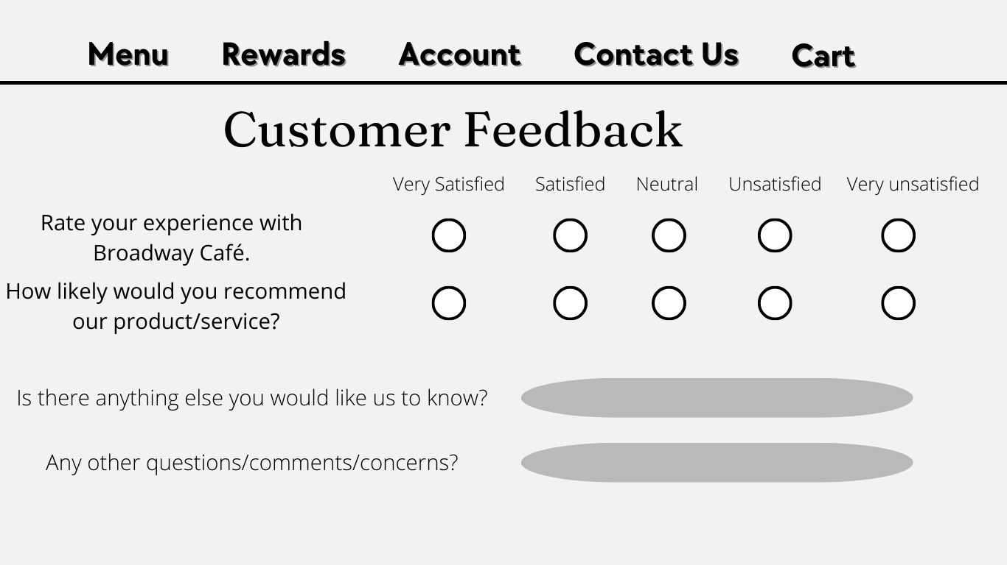

## **Back-end GUI**

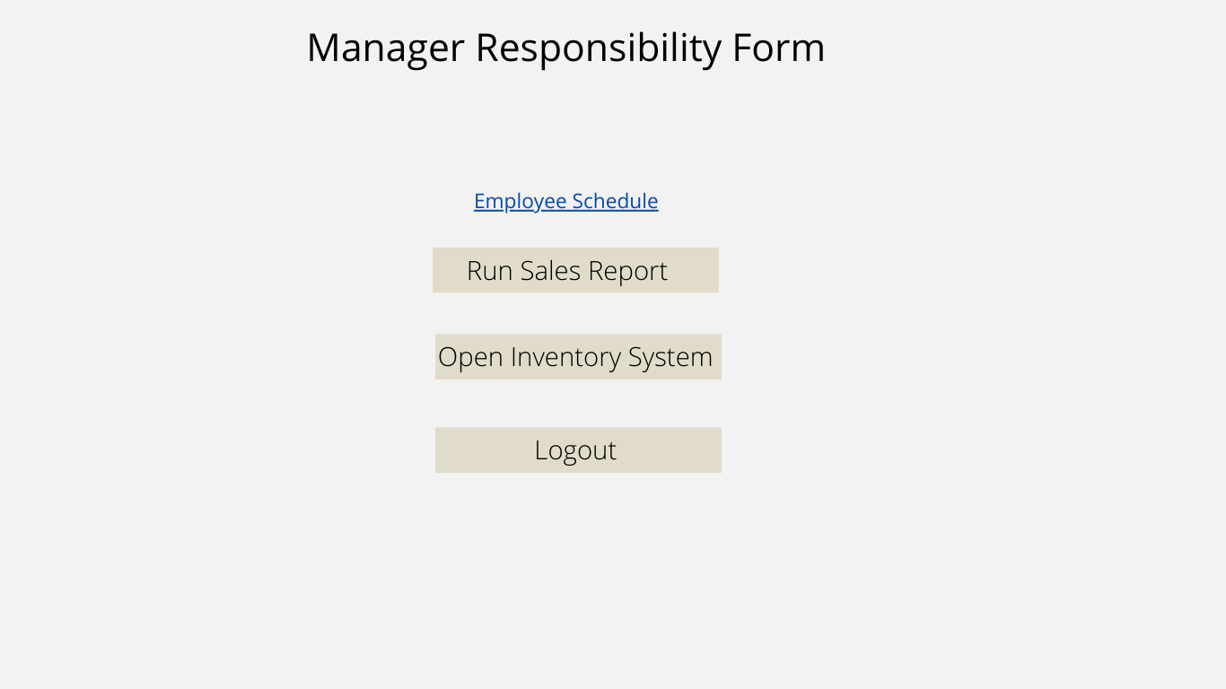

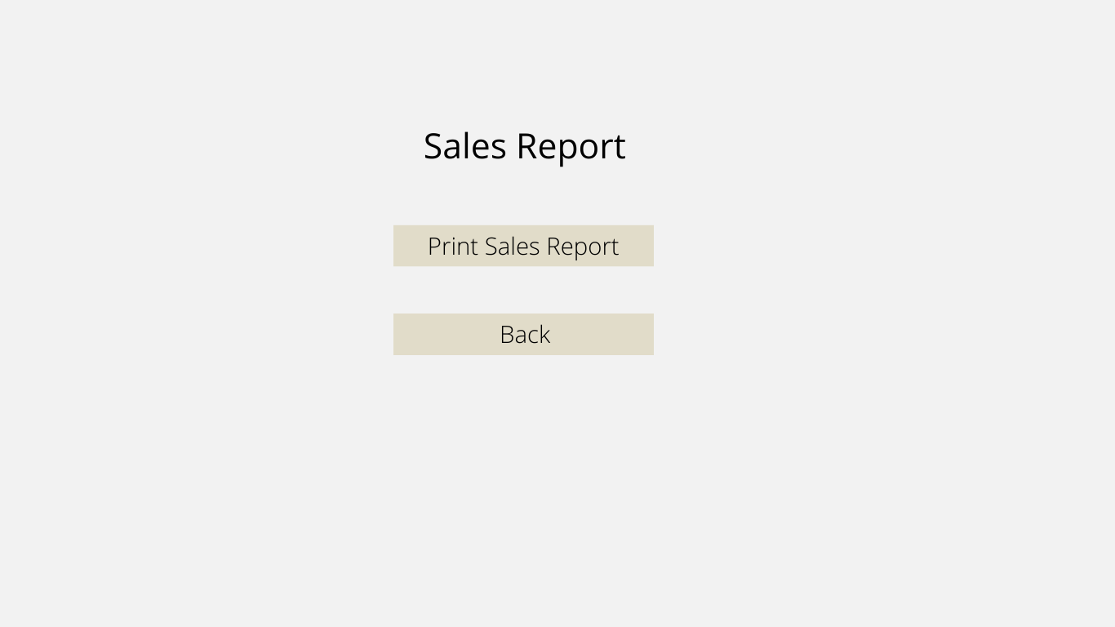

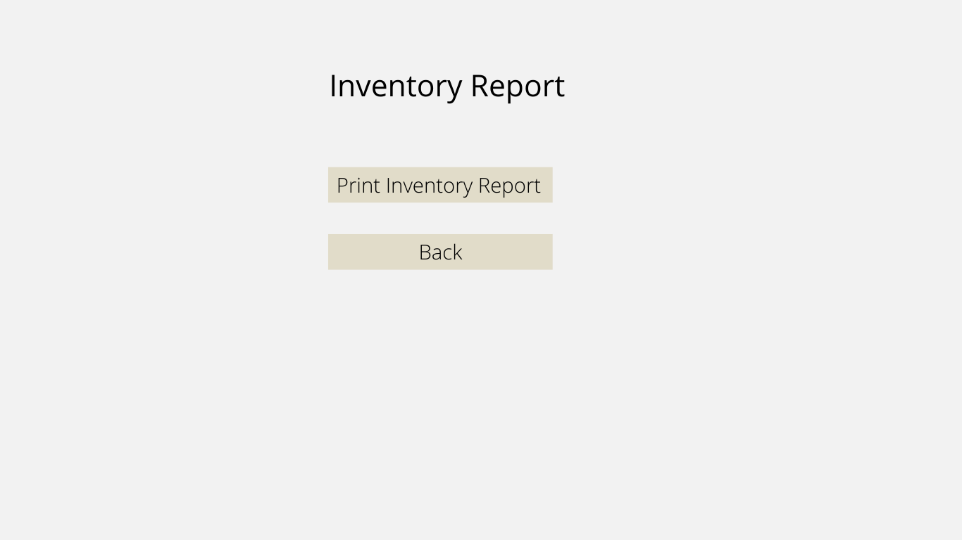

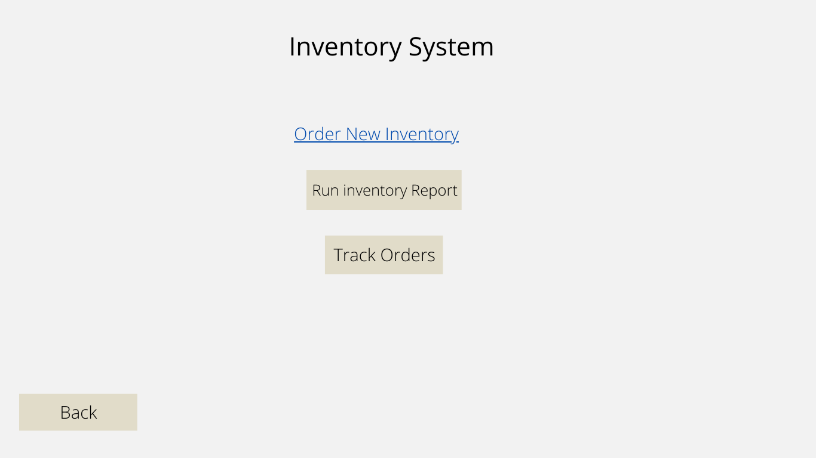

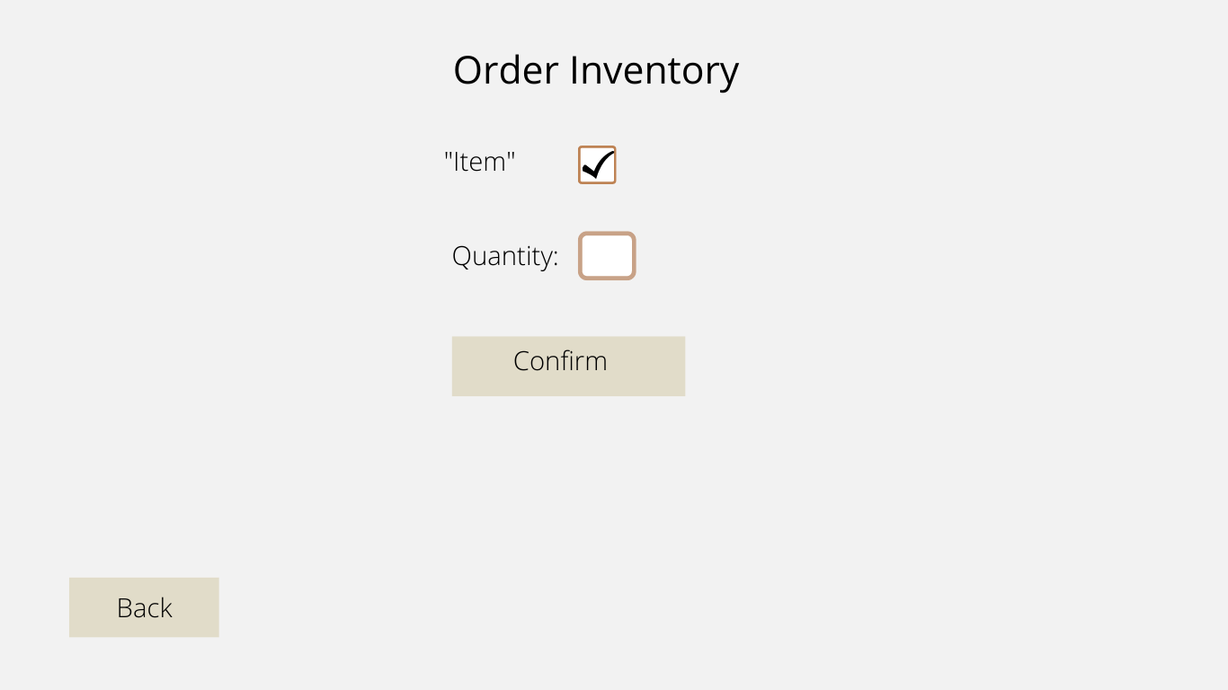

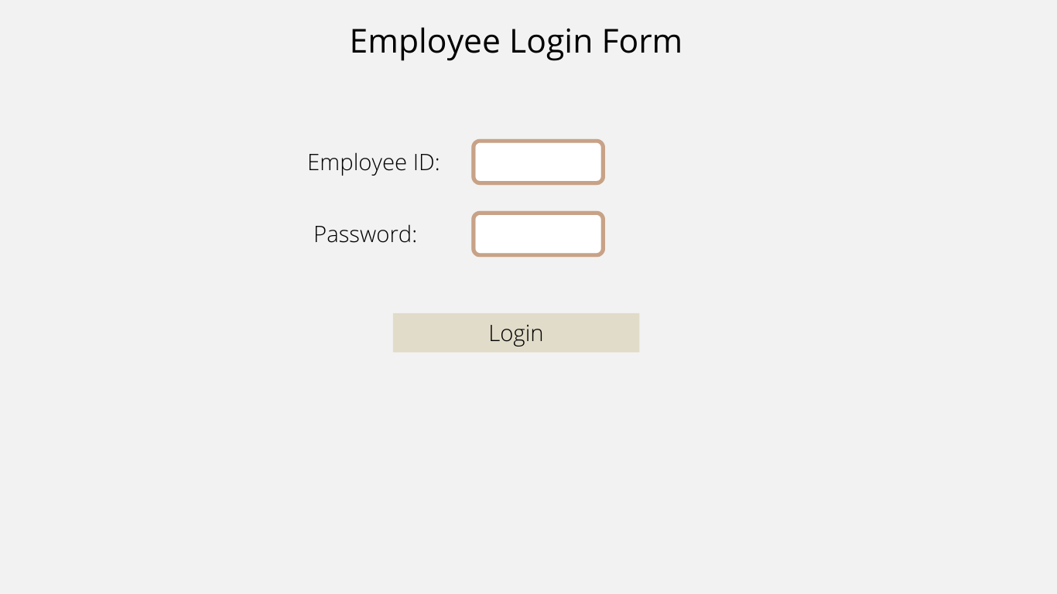

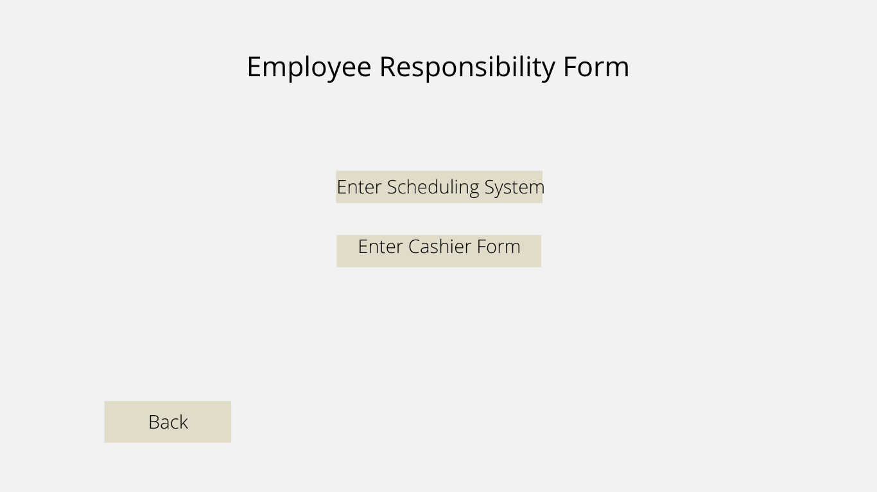

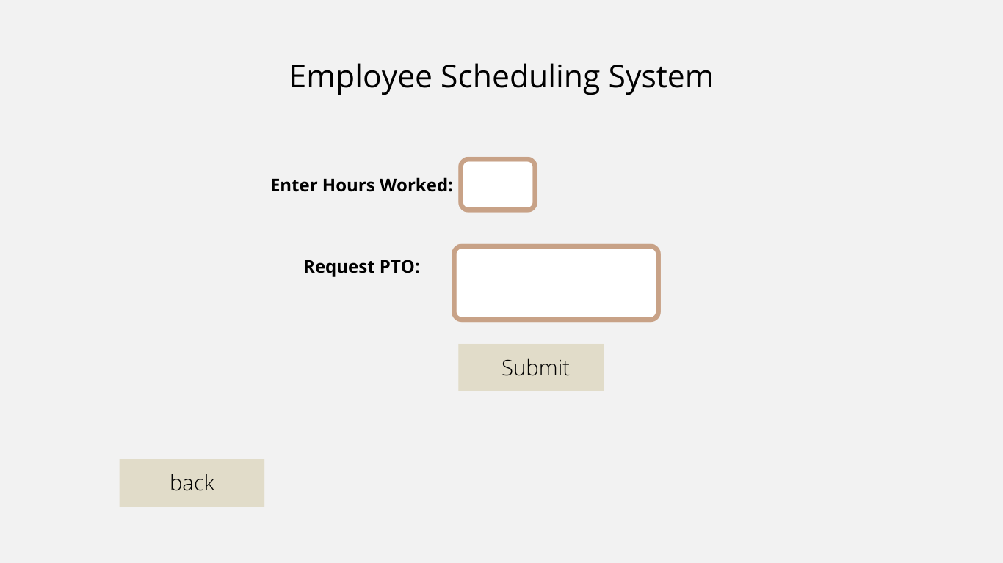

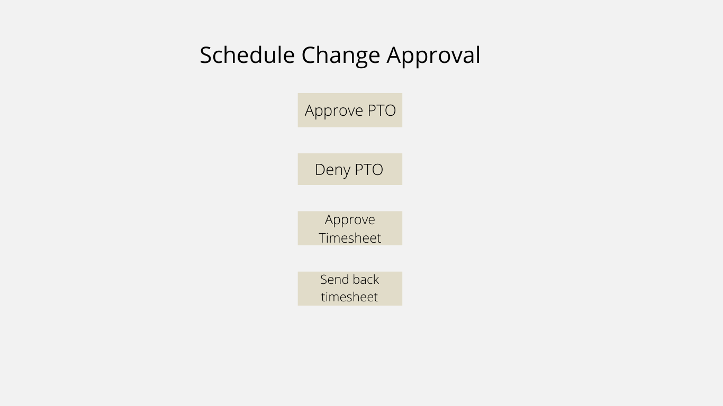

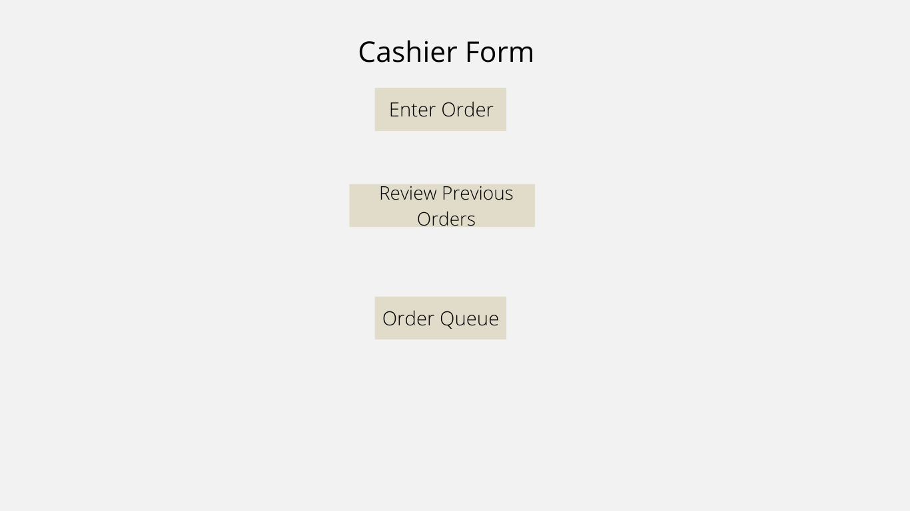

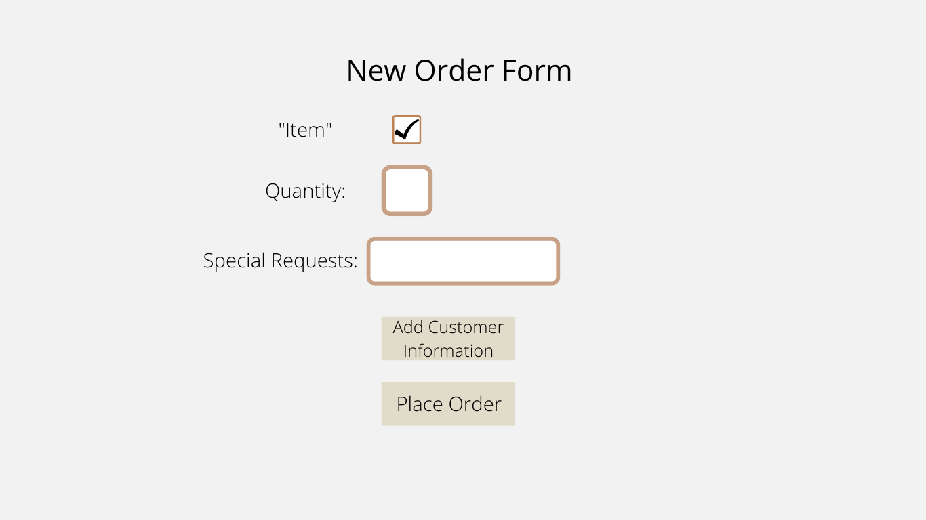

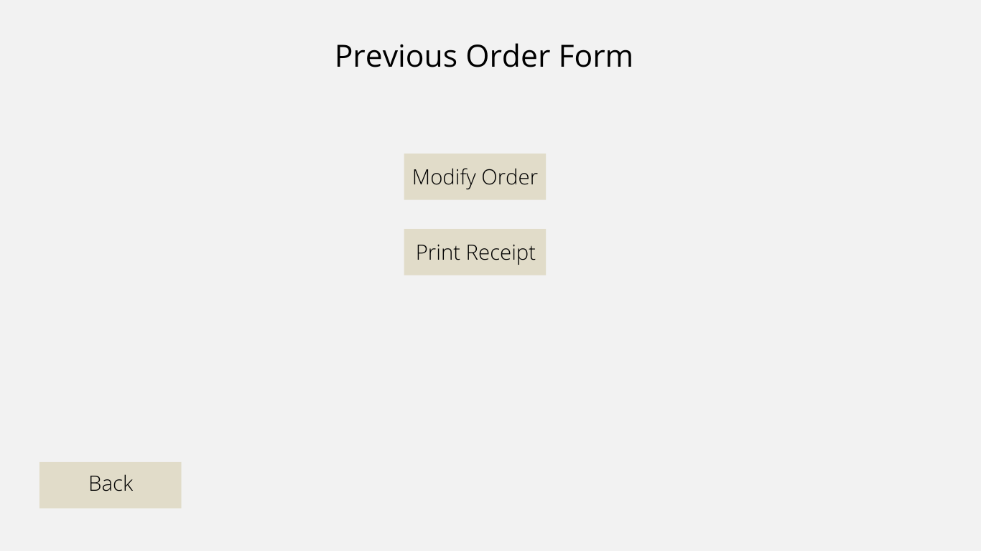

# **Appendix**

# **Project outline:**

**Planning**

Problem statement – Insia Haroon

Project scope- Insia Haroon

Systems request- Melary

Assumptions- Melary

Feasibility analysis (tech, economic, org) - Mohammed

Work breakdown structure (Gantt chart)- Alex Sereleas

**Analysis**

Requirements (functional and non-functional) - Shreya Rawal, Alex

Activity diagram (as-is and to-be) -

As is: Jawad, Melary

To-be: Mohammed

Use case diagram – Shreya and Shriya

**Design**

Design strategy- Shriya

Class Diagram – Vacha Thakkar, Insia

Windows navigation diagram – Jawad, Alex

GUI and forms – Vacha Thakkar and Melary

# **Team Contract**

## **Expectations**

1. Meeting rules:

* Meets on time through zoom if needed and actively participates during zoom calls.
* Be serious about the work
* Be respectful

1. Communication rules:

* Communicates with the entire team
* Gives updates to the team on their progress
* Within 24-hour communication

1. Work Progress

* Completes assigned work thoroughly and on time.
* Even distribution of work within the project
* Reach out for help early instead of waiting closer to the due date.

## **Repercussions**

1. If there is a problem once, we talk it out with group members and act accordingly.
2. Each member gets three strikes. On the second, they will receive fewer credits than the other team members on the project, and on the third, they will receive zero credits and get removed from the project.

**Team Members:**

Mohammed Ganny Signature: **Mohammed Ganny**

Insia Haroon Signature: **Insia Haroon**

Shriyadita Malisetty Signature: **Shriyadita Malisetty**

Shreya Rawal Signature: **Shreya Rawal**

Alexander Sereleas Signature: **Alexander Sereleas**

Vacha Thakkar Signature: **Vacha Thakkar**

Jawad Yousuf Signature: **Jawad Yousuf**

Melary Vasquez Signature: **Melary Vasquez**

# **Works Cited**

Gite, Vivek. “Explain: Five Nines ( 99.999% ) Computer / Network Uptime Concept.” *Explain: Five Nines ( 99.999% ) Computer / Network Uptime Concept*, 2008, https://www.cyberciti.biz/faq/computer-network-uptime-five-nines-999999/.

Rovnaya, Alina. “How to Build Your Own Custom CRM System for Your Business [Extensive Guide].” *Cleveroad Inc. - Web and App Development Company*, 28 Apr. 2022, https://www.cleveroad.com/blog/how-to-build-your-own-custom-crm-system.

Stavytskyi, Krylyo. “How Much Does CRM Software Cost?” *How Much Does CRM Software Cost?*, 23 Apr. 2019, https://mova.io/blog/how-much-crm-costs/.